Name____________________________________________
Two-Way Frequency Table PRACTICE
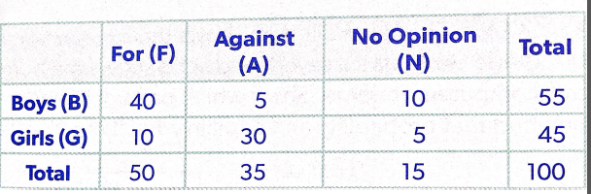
1. Students were asked about a proposal to increase funding for the football program.

Find the probability that a randomly selected student:

A. is a girl
B. is against the proposal
C. is a boy and for the proposal
D. has no opinion and is a girl
E. is against the proposal or is a boy
F. is a girl or has no opinion
G. is for the proposal given that the student selected is a boy
H. is for the proposal given that the student selected is a girl
I. is a boy given that the student selected has no opinion

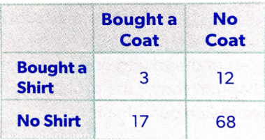
2. 100 people were asked if they bought a coat and/or a shirt at a clothing store that day.

Find the probability that a randomly selected student:

A. bought a shirt
B. did not buy a coat
C. bought a coat and a shirt
D. didn’t buy a coat and didn’t buy a shirt
E. bought a shirt or a coat
F. bought a shirt or did not buy a coat
G. bought a shirt given that the person selected bought a coat
H. did not buy a coat given that the person selected did not buy a shirt
I. bought a coat given that the person selected bought a shirt
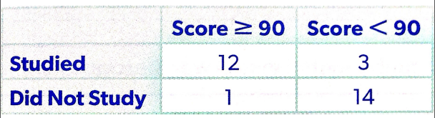
3. A group of students were asked if they studied for a biology quiz.

Find the probability that a randomly selected student:

A. studied
B. scored less than a 90
C. studied and scored less than a 90
D. did not study and scored less than a 90
E. studied given that the student selected scored a 90 or higher
F. studied or scored a 90 or higher
G. studied and scored a 90 or higher
H. scored less than a 90 given that the student selected did not study
I. did not study given that the student selected scored less than a 90

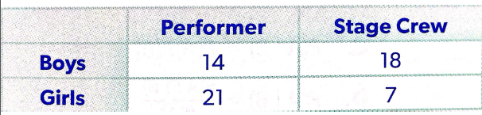
4. A group of students working on a school play were asked if they are performers or stage crew members.

Find the probability that a randomly selected student:

A. is a boy
B. is a boy or a performer
C. is a boy and a performer
D. is a stage crew member
E. is a stage crew member and a girl
F. is a girl or a stage crew member
G. is a girl given that the student selected is a performer
H. is a stage crew member given that the student selected is a boy
I. is a boy or a stage crew member

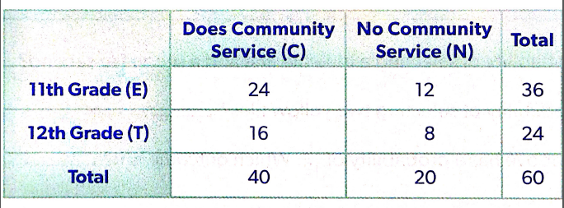
5. The two way frequency table shows the results of a survey of 11th and 12th grade students that were asked if they do community service.

Find the probability that a randomly selected student:

A. is in the 11th grade
B. is in the 11th grade and doesn’t do community service
C. is in the 12th grade and does community service
D. is in the 12th grade or does community service
E. does community service given that the student selected is in the 12th grade
F. is in the 12th grade given that the student selected does community service
G. is in the 11th grade or does not do community service
H. is in the 11th grade given that the student selected does not do community service
I. does not do community service or is in the 12th grade

6. 110 9th-12th graders were asked is they preferred a dog or a cat.
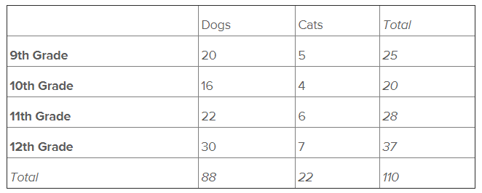
Find the probability that a randomly selected student:

A. is in 10th grade
B. is in 9th grade and prefers dogs
C. is in 12th grade or prefers dogs
D. prefers dogs given that the person selected in the 12th grade
E. is in the 9th grade given that the person selected prefers cats
F. is in the 10th grade or prefers cats
G. prefers cats and is in the 11th grade
H. prefers cats given that the person selected is in the 10th grade
I. is in the 11th grade and prefers cats

