Review Two Way Tables Name:___________________________
Date:___________________Block:____
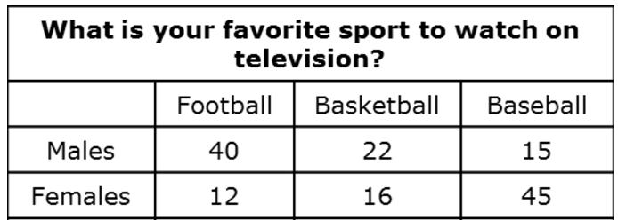

- How many people were surveyed? A.__________________

- If a person was chosen at random, what is the probability
that a female who likes basketball would be chosen? B.__________________

- What is the probability that a person chosen at random is a male or someone that
likes baseball? C.__________________

- What is the probability that a person chosen at random likes football,
given that they are a female? D._________________

- What is the probability that a person is a male, given that they like baseball? E.__________________

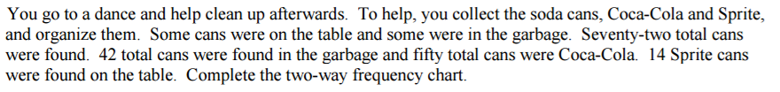

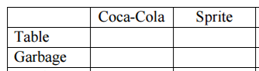
A.

B. What is the probability that a Coca Cola can was found in the garbage? B.__________________

C. What is the probability that a can chosen at random is found on the table
or is a Sprite can? C.__________________

- What is the probability that a can chosen at random is a Coke can
given that the can was found on the table? D._________________

