* **Proof**: A convincing argument that something is true
* Use a series of ***statements*** supported by **reasons**
* Use the **given** information.
* For triangle proofs, use known **definitions, postulates, previously proven theorems**.( For example Right triangle congruence, reflexive property, vertical angles, alternate interior angles, SSS, SAS,ASA, AAS, definition of midpoint )
* **CPCTC**( this stands for “ Corresponding Parts of Congruent Triangles are Congruent”- This can only be used after you proven that two triangles are congruent

**2 Column Proofs**:

Using 2 columns to

organize your

reasoning

Steps : Writing a 2-Column Proof

* Number each Step
* Draw a picture (if one is not provided), mark the given information.
* You must have a reason for EVERY statement ( definitions, postulates, theorems)
* Statements with the same reason can be combined into one step.

**Other properties that can be used in Proofs**

|  |  |
| --- | --- |
| Property | Meaning/Example |
| Reflexive Property | a=a |
| Symmetric Property | If a=b, then b=a |
| Substitution Property | If x + y= z, and y=2, then x + 2= z |
| Transitive Property | If a=b, and b=c, then a=c |

Problem 1: Given:,, Prove that LMN LON

|  |  |
| --- | --- |
| **Statement** | **Reason** |
|  |  |
|  |  |
|  |  |
|  |  |

Problem 2: Given: ,, Prove that QSTTRQ

|  |  |
| --- | --- |
| **Statement** | **Reason** |
|  |  |
|  |  |
|  |  |
|  |  |
|  |  |

Problem 3: Given: ,, Prove that GIHKIJ

|  |  |
| --- | --- |
| **Statement** | **Reason** |
|  |  |
|  |  |
|  |  |
|  |  |

Problem 4: Given: , prove that 

|  |  |
| --- | --- |
| **Statement** | **Reason** |
| 1. | 1. |
| 2. | 2. |
| 3. | 3. |
| 4. | 4. |
| 5. | 5. |
| 6. | 6. |

Problem 5: Given: △UXW and △UVW are right △s,** prove that** X  V

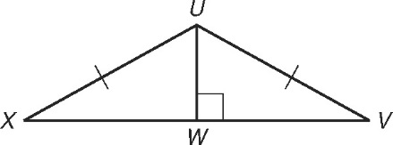

|  |  |
| --- | --- |
| **Statement** | **Reason** |
| 1. | 1. |
| 2. | 2. |
| 3. | 3. |
| 4. | 4. |
| 5. | 5. |
| 6. | 6. |

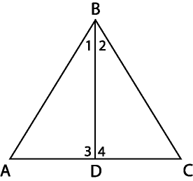Problem 6. **Given:,** D is the midpoint of , **Prove:**

|  |  |
| --- | --- |
| **Statement** | **Reason** |
| 1. | 1. |
| 2. | 2. |
| 3. | 3. |
| 4. | 4. |
| 5. | 5. |
| 6. | 6. |

Problem 7: Given:  and are right angles, prove that

|  |  |
| --- | --- |
| **Statement** | **Reason** |
| 1. | 1. |
| 2. | 2. Right Angle Congruence |
| 3. | 3. |
| 4. | 4. Reflexive Property |
| 5. | 5. |

Problem 8: Given:, prove that 

|  |  |
| --- | --- |
| **Statement** | **Reason** |
| 1. | 1. |
| 2. | 2. |
| 3. | 3. |
| 4. | 4. |
| 5. | 5. |

Problem 9: **Given:,, Prove that **

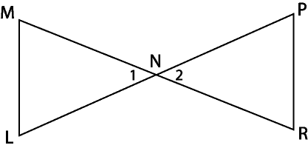

|  |  |
| --- | --- |
| **Statement** | **Reason** |
|  |  |
|  |  |
|  |  |
|  |  |
|  |  |

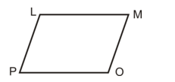

Example 10: Write a two-column proof for the following:

Given: ∠L is supplementary to ∠M, ∠P is supplementary to ∠O, ∠L≅∠O

Prove: ∠P≅∠M

|  |  |
| --- | --- |
| **Statement** | **Reason** |
| 1. | 1. Given |
| 2. L +M =180°, P+O =180 |  |
| 3. | 3. Substitution Property |
| 4. | 4. Given |
| **5.** O+M =P+O | 5. |
| **6.** | 6. Substitution Property |
|  |  |