Unit 5 Review Name:_________________________________

1. Find the midpoint of the segment with the following endpoints:
2. (-8, 3) and (4, -7) B. (1, 9) and (-3, 7)
3. Find the slope of the line that contains the points:
4. (-8, 5) and (2, 9) B. (10, -2) and (-2, -6)
5. Find the distance between the two points:
6. (-7, 3) and (5, -2) B. (4, -8) and (-6, -3)

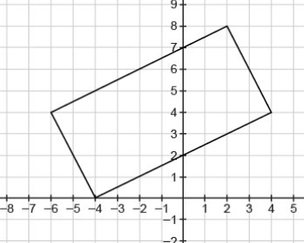

1. Find the area and perimeter of the rectangle:

Area:

Perimeter:

1. Use either method (showing diagonals are congruent using the distance formula OR by showing the diagonals bisect each other using the midpoint formula) to prove the figure in #4 is a rectangle.
2. Write the linear equation for the line that passes through the given point and has the given slope:
3. m=2/3, (-9, 2) B. m= -5/4, (8, -3)
4. Write the equation of the line that is **parallel** to the given line and passes through the given point:
5. y=x + 5, (-12, 3) B. y=x – 2, (6, 7)
6. Write the equation of the line that is **perpendicular** to the given line and passes through the given point:
7. y=x – 3 (3, -4) B. y=x + 4 (4, -2)
8. Name the center and radius of the circle with the equation:
9. (x-2)2 + (y+5)2 = 36 B. (x+7)2 + (y-3)2 = 121
10. Write the equation of the circle with the given center and radius:
11. C(4, -5), r=2 B. C(-9, -6), r=5
12. Factor the following:
13.  B. 
14.  Change forms from general to standard form for the equation of a circle.
15. B.