Proofs in the Coordinate Plane Armstrong
For #s1-2 find the length of the diagonals. For #s3-4 use the midpoints.
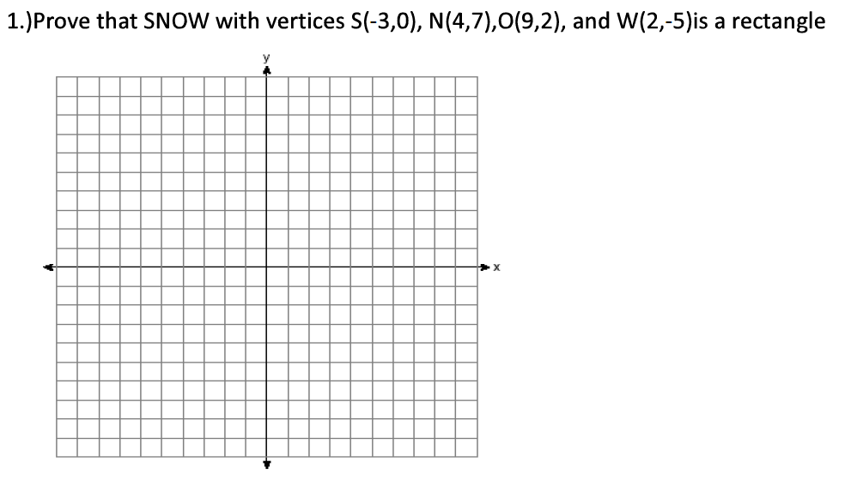

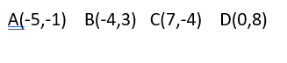
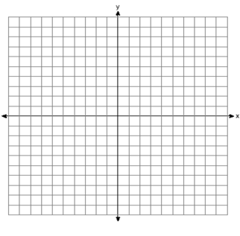
2. Prove that ABCD with vertices is a rectangle.

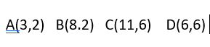
3. Prove that ABCD with vertices is a rectangle.

4. Prove that EFGH with vertices E(-4, 5), F(0, 8), G(6, 0), H(2, -3) is a rectangle.

