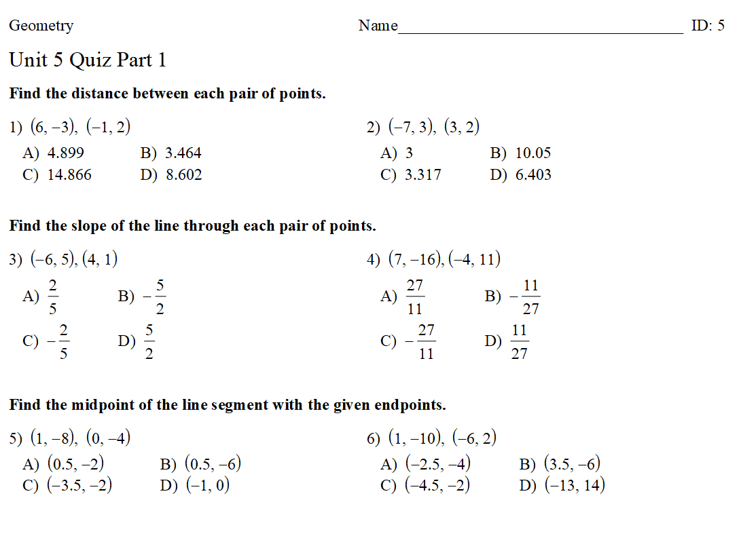

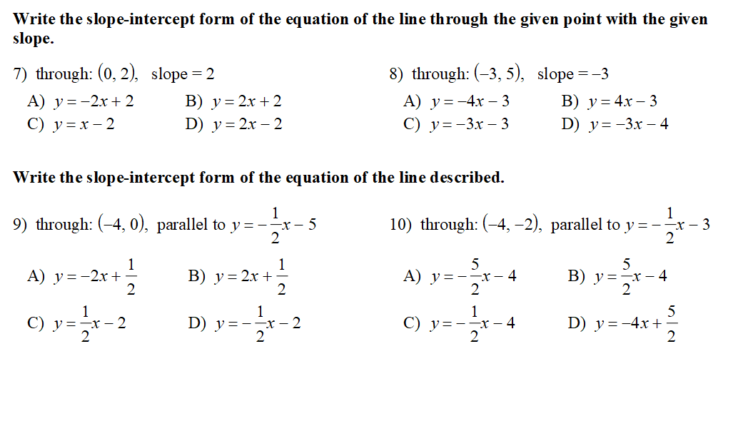

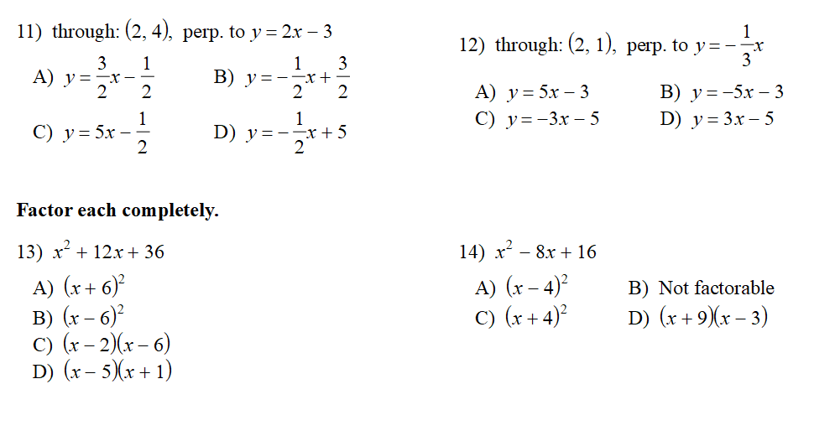

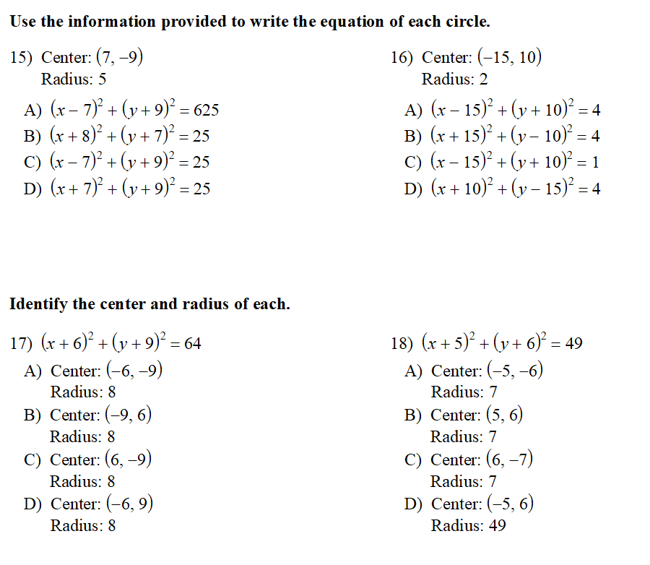

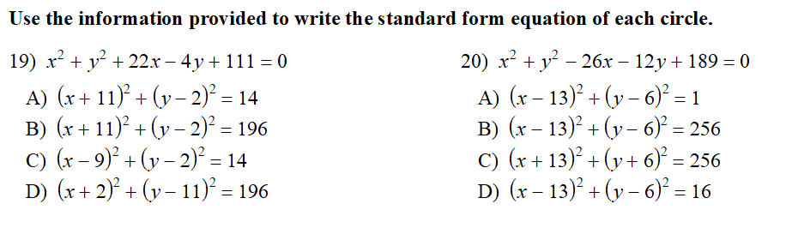

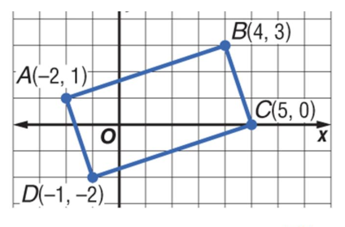
Use the image to answer the following questions.
21. The area of the rectangle is:
A. 16 B. 20
C. 17 D. 19

22. The perimeter of the rectangle is: 23. The length of the diagonals is:
A. 16 B. 20 A. 7.1 B. 3.2
C. 17 D. 19 C. 5.8 D. 6.3

24. The coordinates of the midpoints are:
A. (1.5, .5) B. (-3.5, .5)
C. (-.5, 2.5) D. (2.5, .5)

