Quiz Two Way Tables Name:___________________________
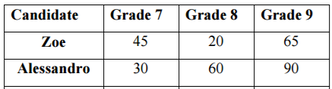
Date:___________________Block:____

- What is the total number of students that voted? A.__________________
- If a student was chosen at random, what is the probability
That a 7th grader voted for Alessandro? B.__________________

- If a student is chosen at random, what is the probability
that the student is in 8th grade or has voted for Zoe? C.__________________

- What is the probability that a student chosen at random is in 9th
grade, given that they voted for Alessandro? D._________________

- What is the probability that a student chosen at random voted for
Zoe, given that they are in 8th grade? E.__________________

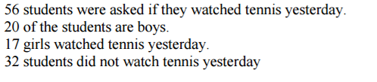

 | Watched Tennis | Didn’t Watch Tennis
Girls
Boys
- Complete the chart.

- What is the probability that a boy watched tennis? B.__________________

- What is the probability that a student chosen at random is a girl or
didn’t watch tennis? C.__________________

- What is the probability that a student watched
tennis, given that they are a boy? D. _________________

- What is the probability that a student is a E.__________________
girl, given that they didn’t watch tennis?

