Area and Perimeter in the Coordinate Plane Armstrong

Find the area and perimeter of each of the following:
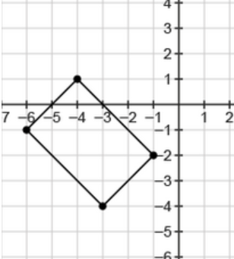
- Area=_______________

Perimeter=_______________

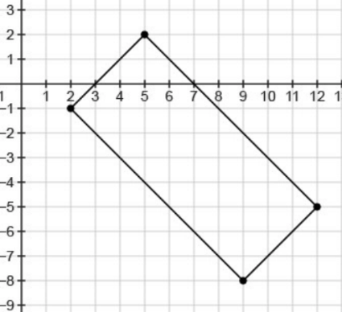
- Area=_______________

Perimeter=_______________

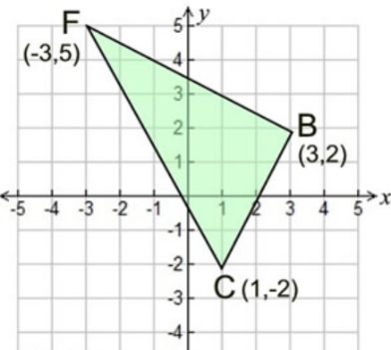

Area=_______________

Perimeter=_______________

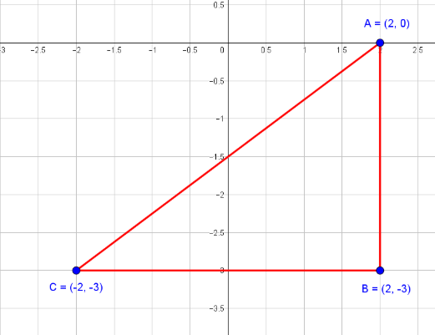
Area=_______________

Perimeter=_______________

