Parallel Lines and Transversals

|  |  |  |
| --- | --- | --- |
| Word | Meaning | Example/Symbol |
| Parallel Line | Lines that do not intersect  ( usually shown by arrows on the lines) | L  Line L Line M M  M |
| Transversal | A line that intersects two or more lines at two different points.  Line ***t*** is a transversal  When a transversal intersects two parallel lines, eight angles are formed. |  |
| Interior Angles | Angles inside the parallel lines |  |
| Alternate interior angles | Angles inside the parallel lines and on opposite sides of the transversal.  They are always **congruent** |  |
| Consecutive interior angles | Angles on the same side of the transversal and inside the parallel lines  They are **Supplementary** ( Add up to 180°) |  |
| Exterior Angles | Angles outside the parallel lines. |  |
| Alternate Exterior Angles | Angles on opposite sides of the transversal and outside the parallel lines  They are always **congruent**. |  |
| Corresponding angles | Angles in matching corners of the transversal.  They are always **Congruent** |  |
| Linear Pair | Two angles that are adjacent (next to each other and share a side) and supplementary (add up to 180o) |  |
| Vertical Angles | Two angles that are formed by intersecting lines. They are across from each other. |  |

**Example 1**: In each diagram below, Find the measure of angle 1 and angle 1, justify your answer.



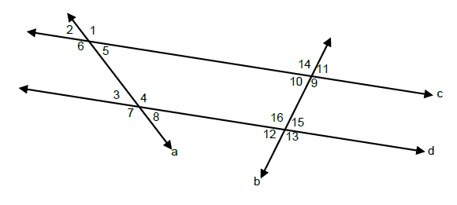**Example 2**. In the diagram below, line *c* || line *d*, and lines a and b are transversals. If the measure of angle 3 is 65° and the measure of angle 15 is 85°. Find the measures of all the angles. Justify your answer

**Angle Justification**

m<1 = ______

m<2 = _______

m<3= _______

m<4= _______

m<5= ________

m<6= ________

m<7= _________

m<8 = ________

m<9= _______

m<10= _________

m<11= _________

m<12 =__________

m<13= ___________

**Example 3a**: Solve for x, then find the measure of each angle.

3b) Solve for x, then find the measure of each angle