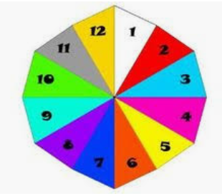Intro to Compound Probability Armstrong

P(A and B)=P(A) × P(B)

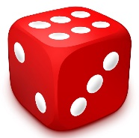

Directions: Determine the probability of one event, then determine the probability of the second event, then multiply the two probabilities.

1. What is the probability of spinning a 2 and rolling a 5? ___________________

Answer:  x  =

1. What is the probability of spinning an even # and rolling a 3? ___________________
2. What is the probability of spinning a 3 and rolling an odd number? ___________________
3. What is the probability of spinning and landing on yellow and rolling an even #? ___________________
4. What is the probability of spinning a 3, 4, or 5 and rolling a 3, 4, or 5? ___________________
5. What is the probability of spinning an odd # and rolling a number less than 4? ___________________
6. What is the probability of spinning a number more than 7 and rolling a 6? ___________________
7. What is the probability of spinning a number less than 5 and rolling an odd #? ___________________
8. What is the probability of spinning a 2 and rolling a number less than 5? ___________________
9. What is the probability of spinning a number more than 7 and rolling a number less than 5? ­­­­­­­­­­­­­­­____________