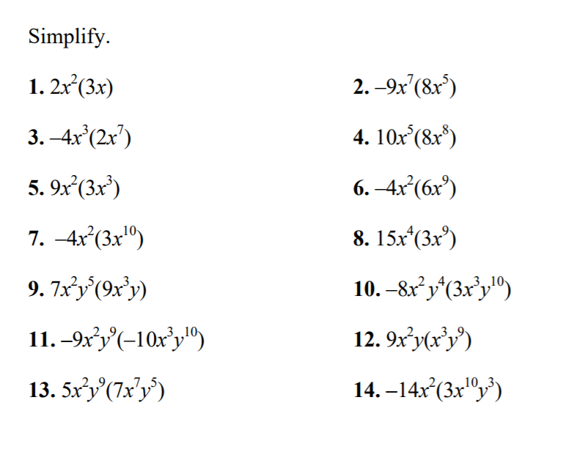 Name:___________________________